Python 101: The Ultimate Python Tutorial For Beginners
Dennis Macharia Njogu
Published in Lux Tech

Python is among the most in demand programming languages and this is because Python has friendly syntax which makes it easier for novice programmers to learn. In this document we will work through two Python programs; one program will check whether a number is a prime number and the other will check whether a number belongs to the Fibonacci series or not.
- Python Program to check whether a number is a prime or not.
Prime numbers are natural numbers that are divisible by only 1 and the number itself. In other words, prime numbers are positive integers greater than 1 with exactly two factors, 1 and the number itself. Some of the prime numbers include 2, 3, 5, 7, 11, 13, etc.
Here is the Python function to test whether a number is a prime

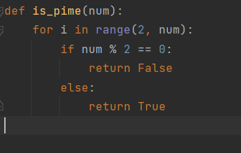

Let’s parse the above function definition
def is_prime(num):
This function takes a positive number num as the argument.
for i in range(2, num):
return False
else:
Return True
The for loop iterates all numbers from number 2 to num – 1.
range(start, stop, step) creates a sequence of numbers from start 0 by default and increments by 1 and stops before the specified number. In this case, the starting value is 2 and the ending value is the number defined as the argument. We start with 2 since 2 is the smallest prime number.
If num % i == 0:
This line checks whether num is divisible by i. The % operator is used to return the remainder of the division between num and i. If the remainder is 0 then num is divisible by i hence returning False as the number is divisible by another number.
The function returns true only if the number has a remainder proving the number is only divisible by 1 and itself.

Now, let’s call the function with arguments and verify if its output is correct:
print(is_prime(8))
#False
print(is_prime(7))
#True
print(is_prime(6))
#False
print(is_prime(11))
#True

- Python function to check whether a number belongs to the Fibonacci sequence or not.

The Fibonacci sequence is a set of integers(Fibonacci numbers) that starts with zero followed by one, then another one, and then by a series of steadily increasing numbers. This sequence follows the rule that each number is equal to the sum of the preceding two numbers.
Here is an example of the Fibonacci sequence
0,1,1,2,3,5,8,13,21,34,55,89,…
Each number starting with the third, adheres to this prescribed formula. For example
0 + 1 = 1
1+2 = 2
2 +1 = 3
3+ 5 = 8
13+8 = 21

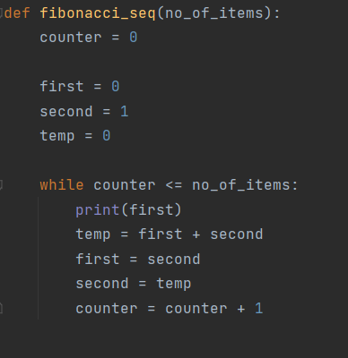
def Fibonacci_seq(no_of_items) :
The function takes the no_of_items as an argument.
The function initializes four variables counter, first,second and temp. The variable counter is used to keep track of the current Fibonacci number. The variables first and second hold the first and the second Fibonacci numbers in the sequence respectively. The temp variable is used as a temporary placeholder in the while loop.

While counter <= no_of_items:
Ensures that the loop runs as long as the value of the variable counter is less than the value in no_of_items provided in the function argument.
Print(first) : Prints the first number in the sequence. In this case it is zero. 0
temp = first+ second : The variable temp holds the value of the first + second variable 0+1 = 1 temp = 1
first = second: We assign the value of the variable first to the value held of variable second.
first = 1
second = temp: We update the value of the variable second to the value held by variable temp. second = 1
counter = counter + 1 : We increment the value of the counter by one on each iteration.

On the second iteration the value printed will be 1, temp = 2, first = 1, second = 2, counter = 2 and so on until the counter is equal to the no_of_items where the while loop will break.

Conclusion
We have covered two helpful Python functions in this document. While the second function detects whether a number is a part of the Fibonacci sequence, the first function determines whether a number is a prime number.

It is essential for many mathematical algorithms and applications to be able to identify numbers that have only themselves and the number one as divisors. This is made possible by the prime number function. On the other hand, we may identify numbers that adhere to a particular pattern thanks to the Fibonacci function.

Thanks for reading!

